EXEC sp_attach_db @dbname = 'New Students',

@filename1 = 'D:\Users\zhong\桌面\实验四数据库用例\实验四数据库用例\DB_Course_Data.MDF',

@filename2 = 'D:\Users\zhong\桌面\实验四数据库用例\实验四数据库用例\DB_Course_Log.LDF'

一1

select *

from Student1

where Sage>20;

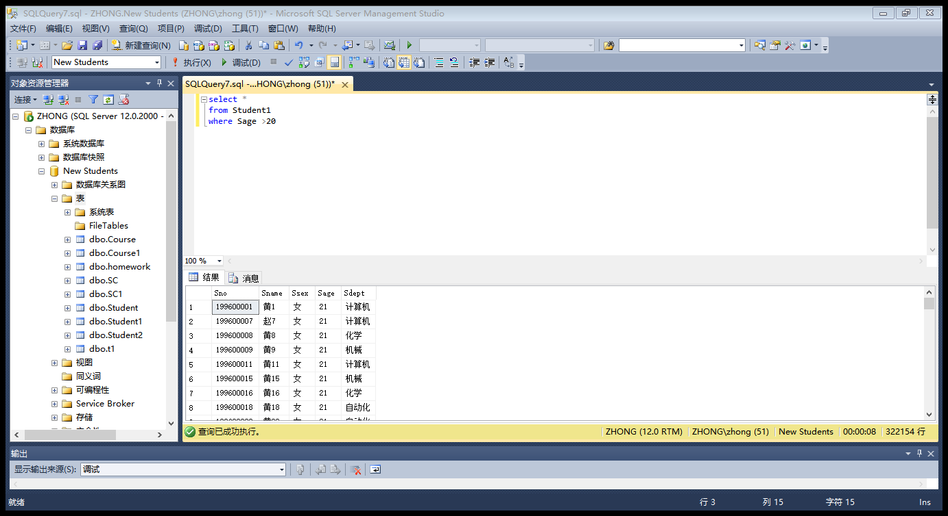

8.631秒

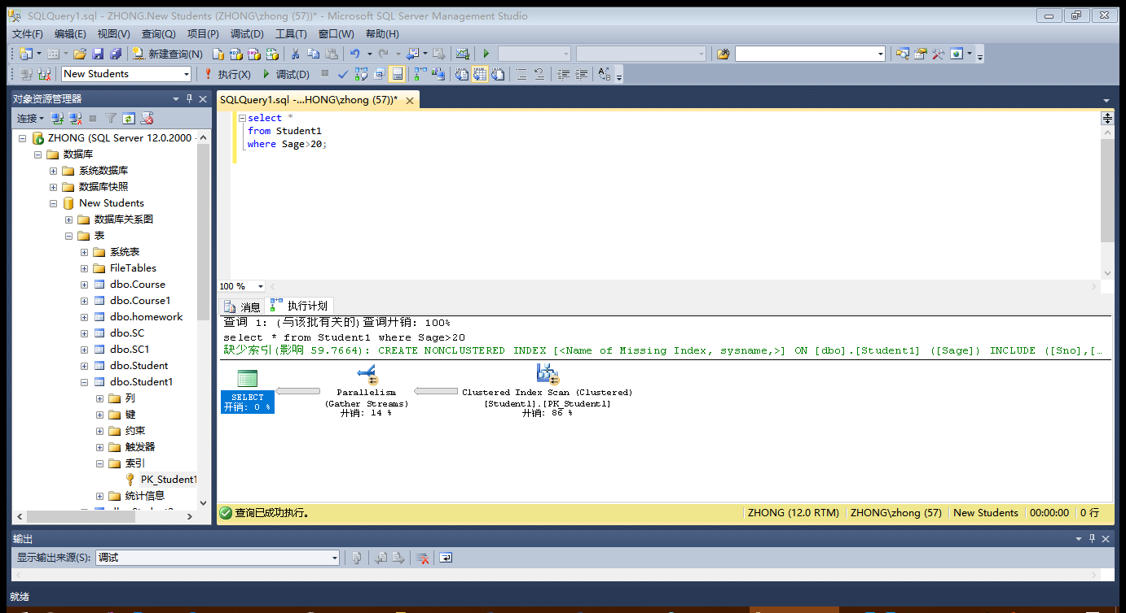

2

create index Sage on Student1(Sage)

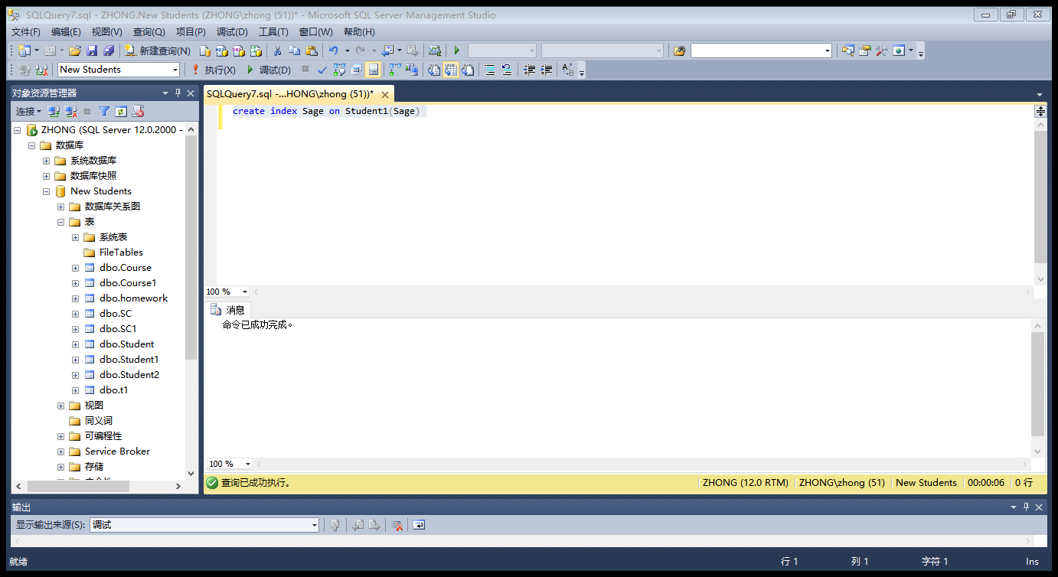

select * from Student1 with(index(Sage))

where Sage>20

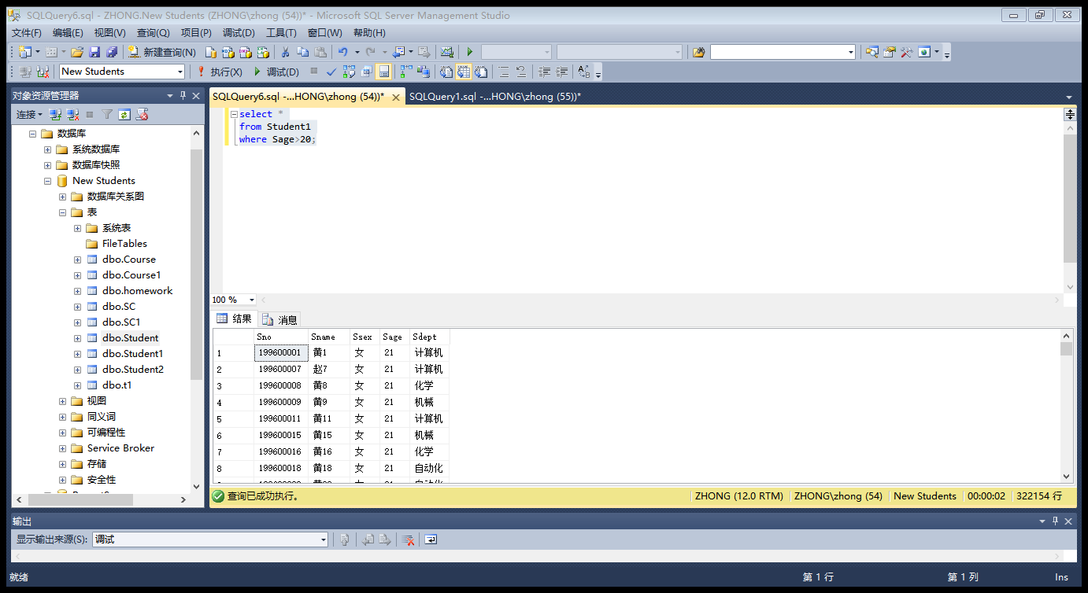

9.860秒

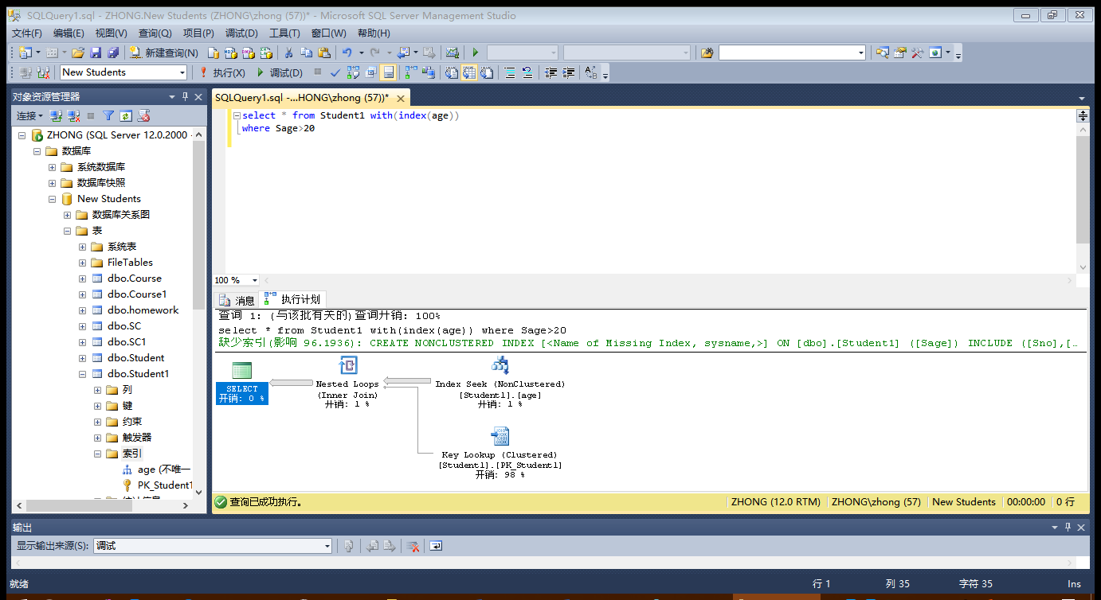

3

select *

from Student1

where Sage>20

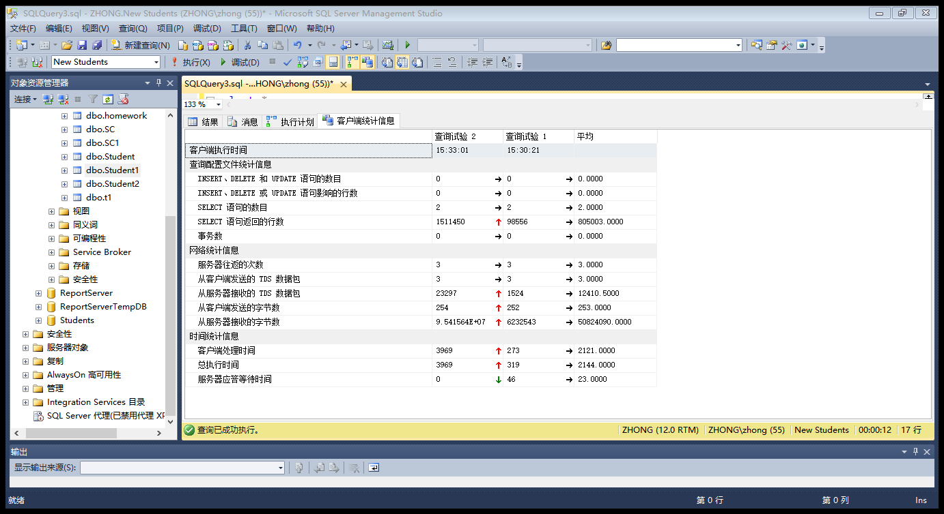

4

select *

from Student1

where Sage>20

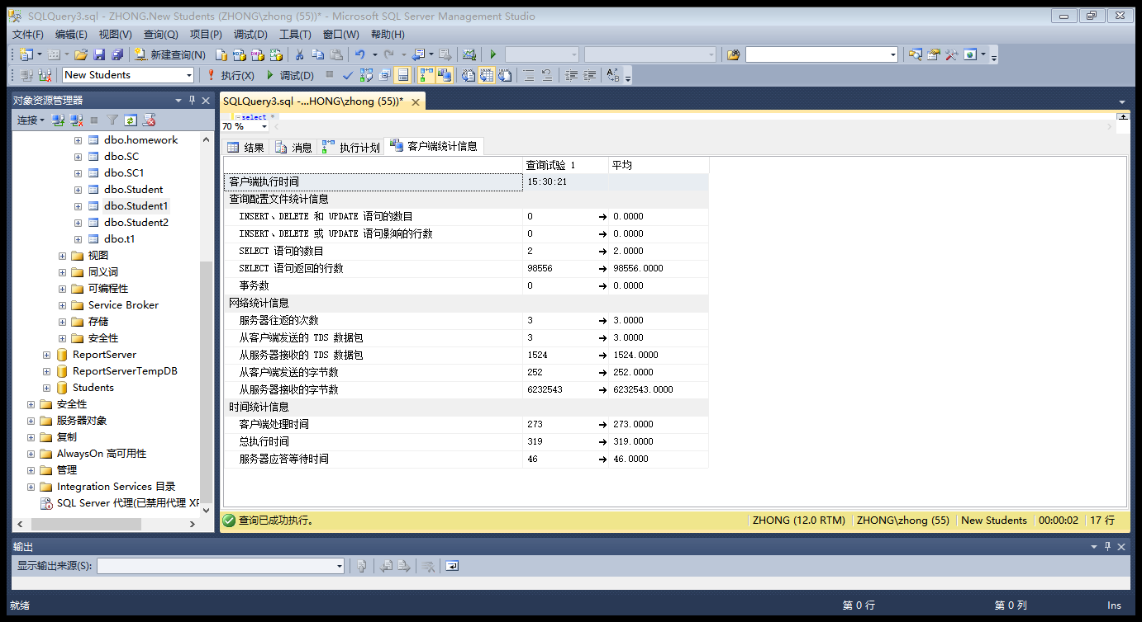

二

1

select student1.Sno,Sname

from Student1,SC1,Course1

where Student1.Sno = SC1.Sno and

SC1.Cno = Course1.Cno and

Course1.Cname like'信息%'

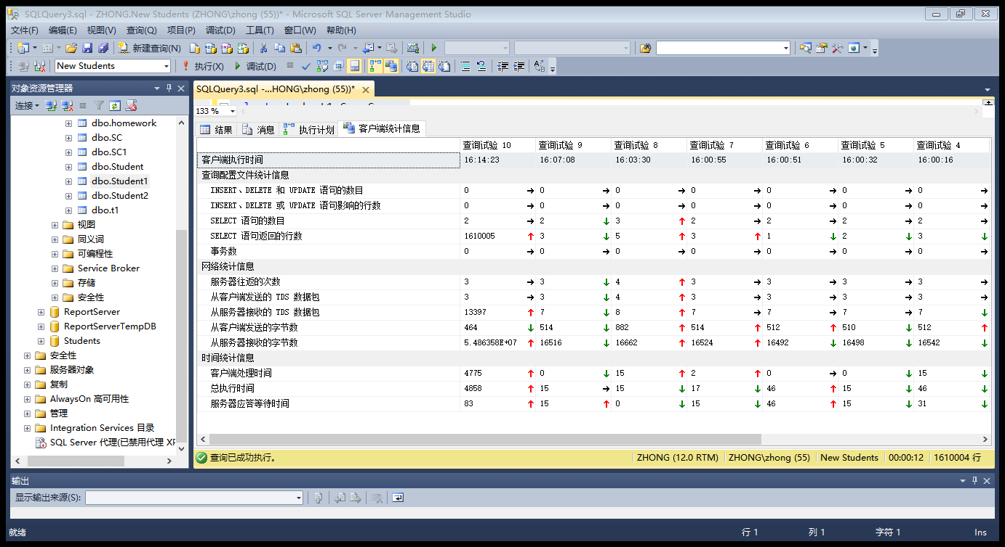

2

select Sno,Sname

from Student1

where Sno in (select Sno

from SC1

where Cno in (

select Cno from Course1

where Cname like'信息%'

)

)

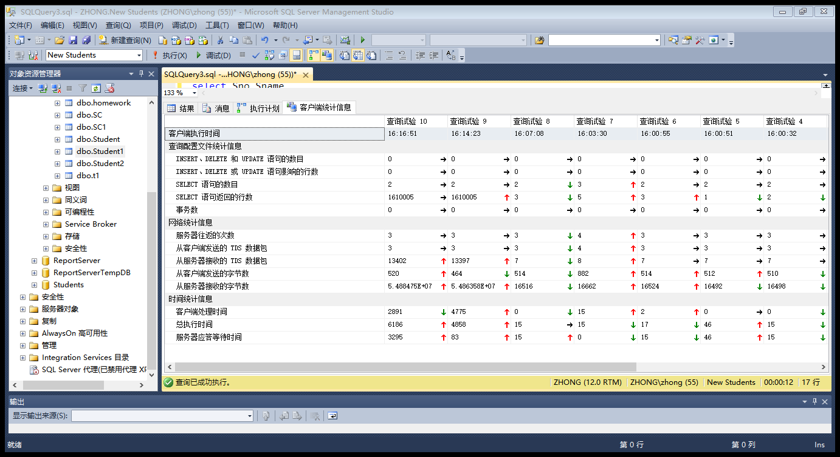

3

create index sname on Student1(Sname,Sno)

create index sno on SC1(Sno)

create index cno on Course1(Cno)

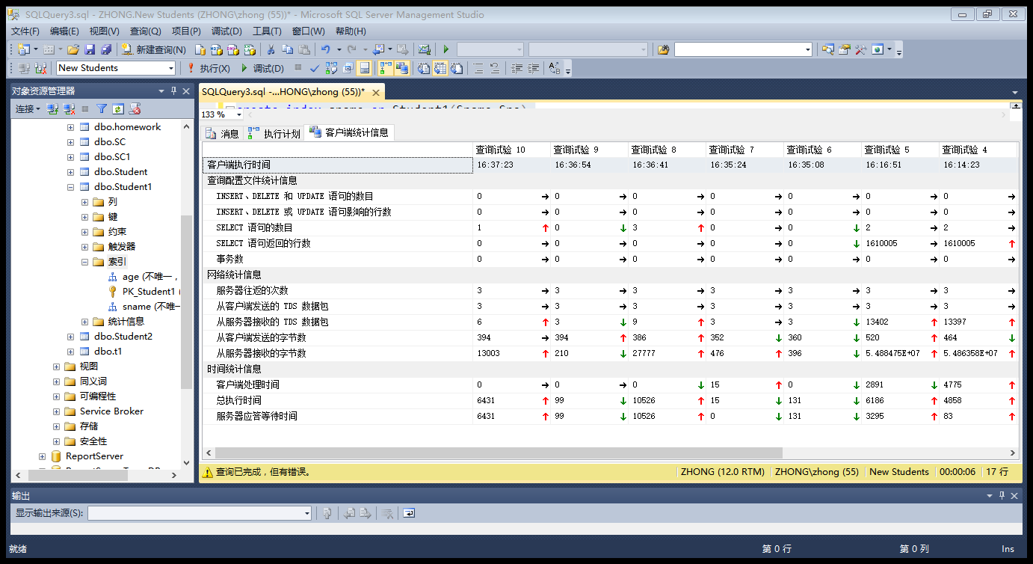

select Sno,Sname

from Student1

where Sno in (select Sno

from SC1

where Cno in (

select Cno from Course1

where Cname like'信息%'

)

)

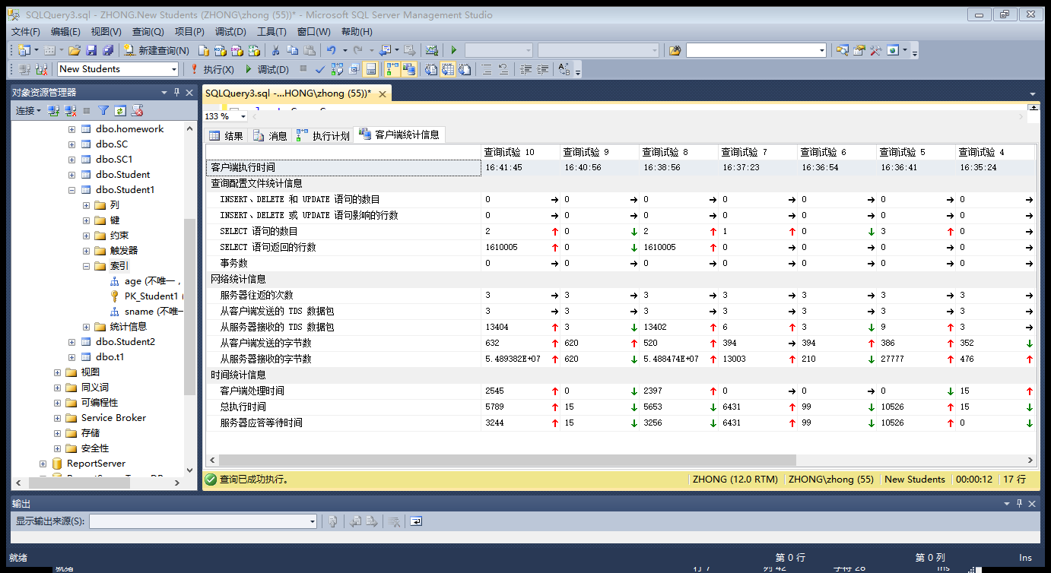

三

1.

温7D3B3F

select *

from Student1

where Sname = '温7D3B3F'

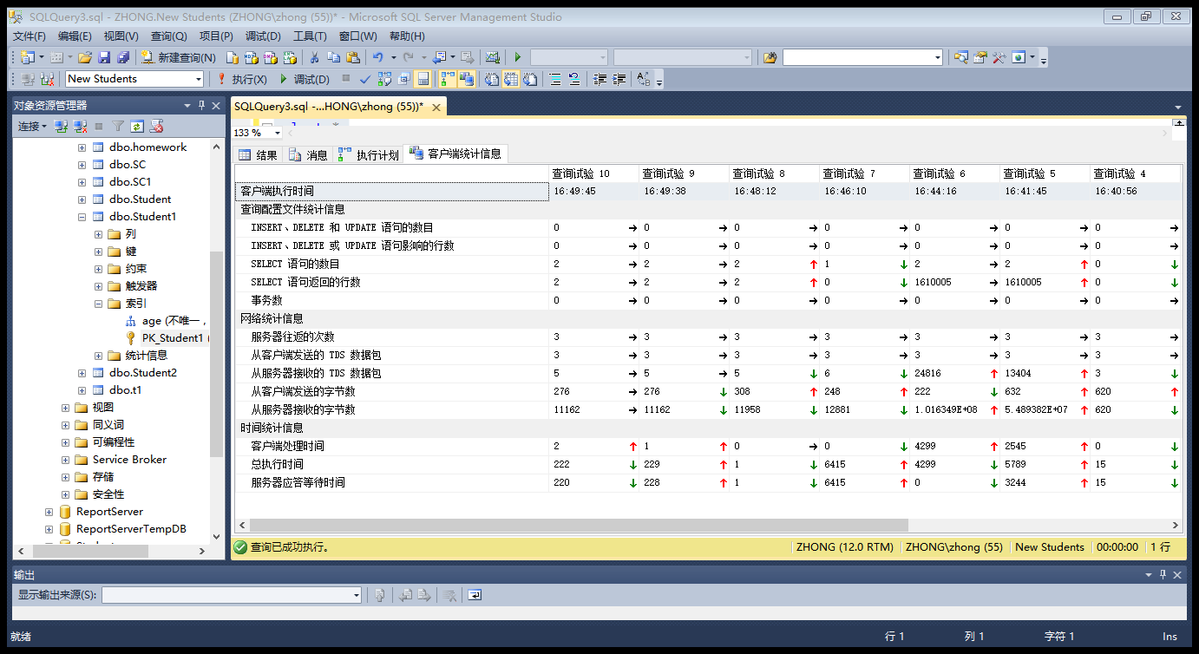

2.

温7D3B3F

create index name on student1(Sname)

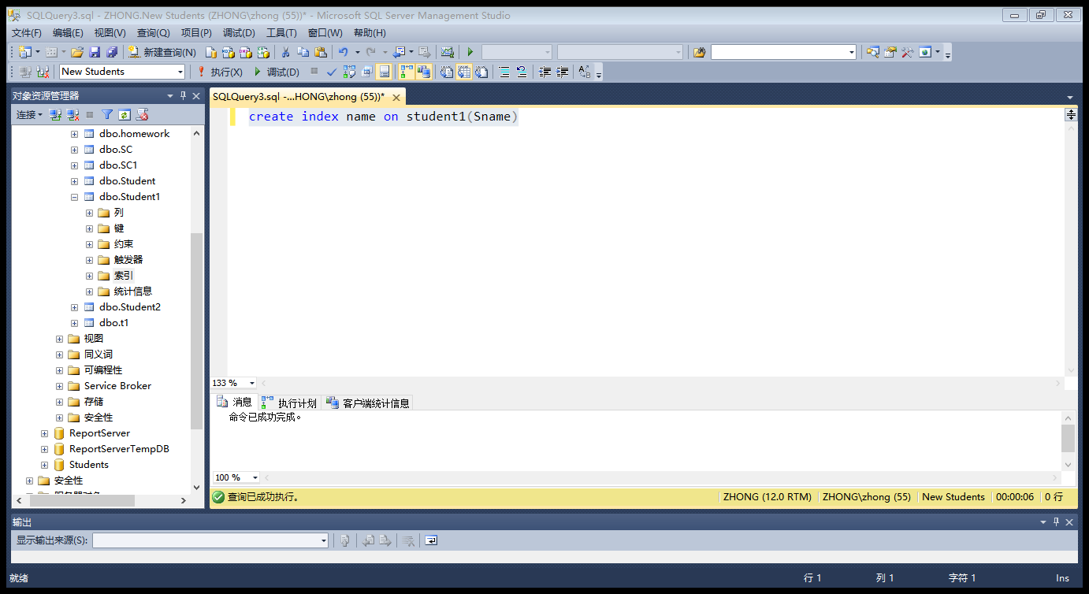

select *

from Student1 with(index(name))

where Sname = '温7D3B3F'

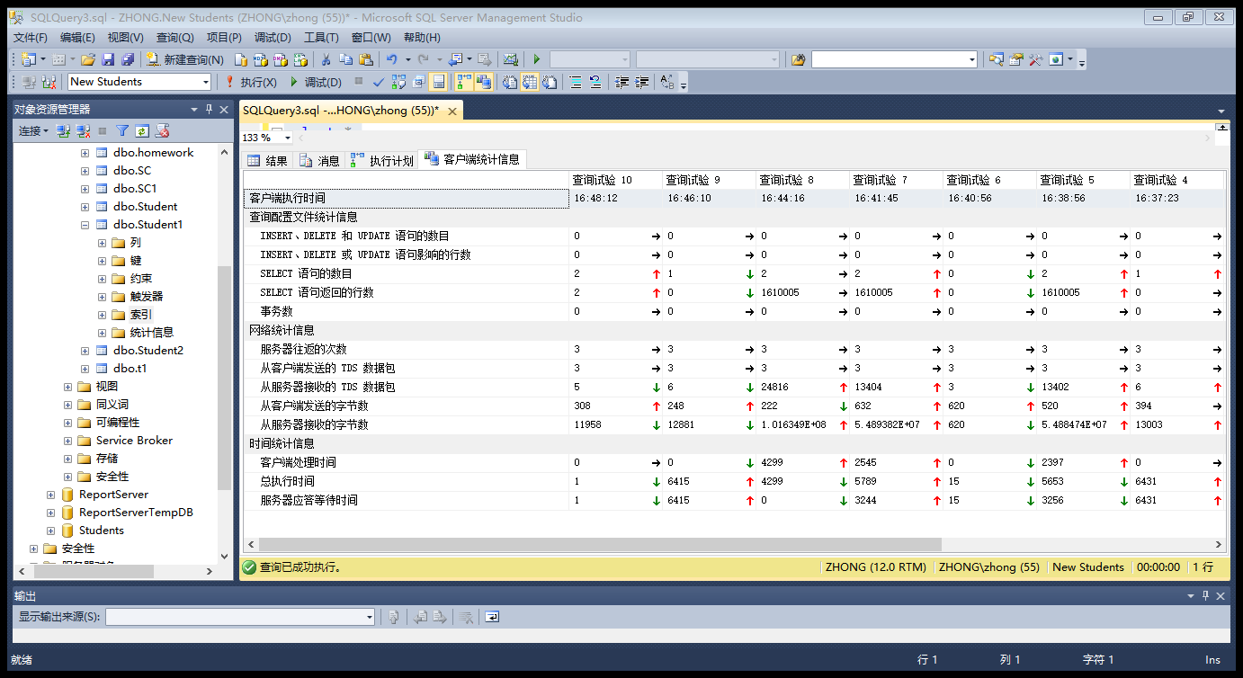

3.

select * from Student1 where Sdept = '海运'

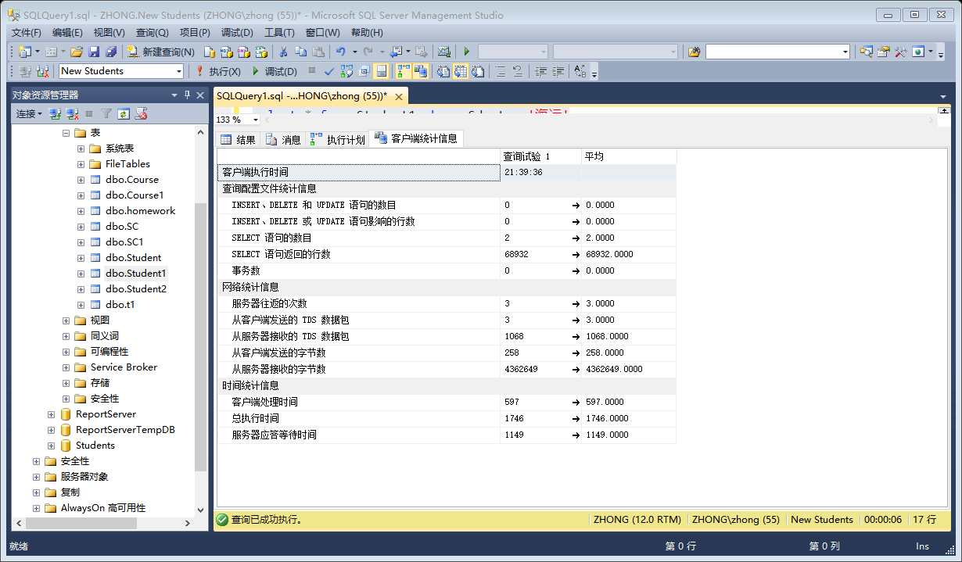

4

create index dept on Student1(Sdept)

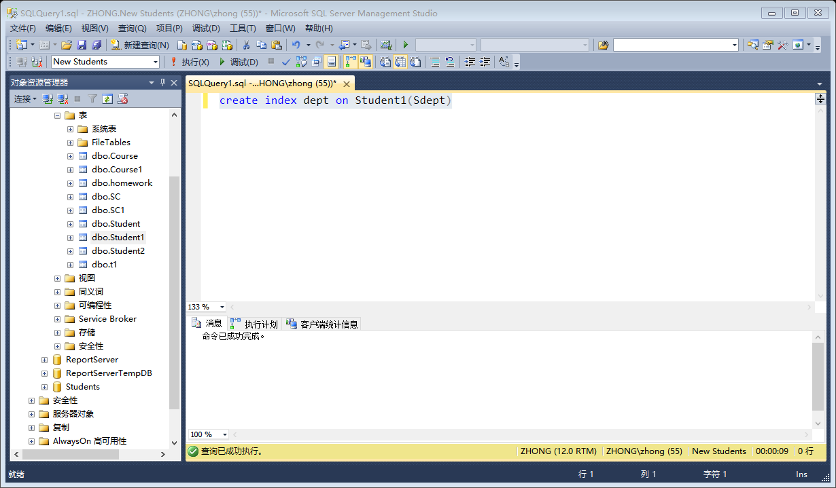

select * from Student1 with(index(dept))

where Sdept = '海运'

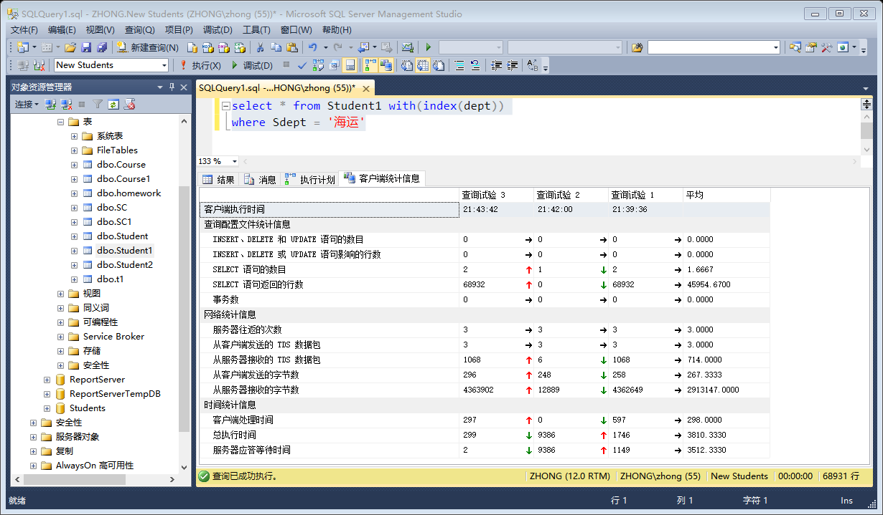

5

select * from SC1

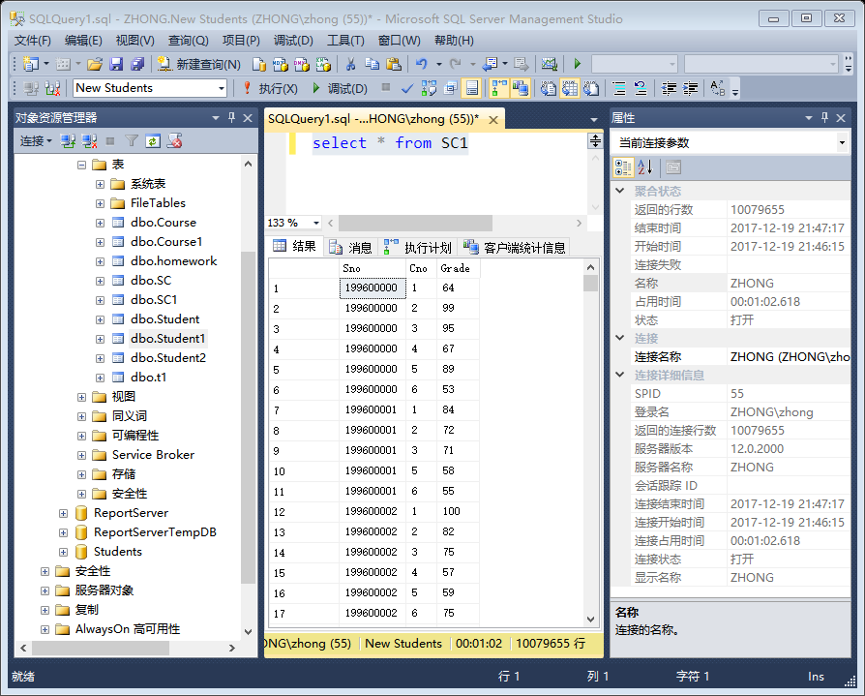

6

select * from SC1,Student1

where Student1.Sno = SC1.Sno

在执行批处理时出现错误。错误消息为: 引发类型为“System.OutOfMemoryException”的异常。

7.

select * from SC1,Student1,Course1

where Student1.Sno = SC1.Sno and

SC1.Cno = Course1.Cno

在执行批处理时出现错误。错误消息为: 引发类型为“System.OutOfMemoryException”的异常。

8

select student1.Sno,Sname

from Student1,SC1,Course1

where Student1.Sno = SC1.Sno and

SC1.Cno = Course1.Cno and

Course1.Cname like'信息%'

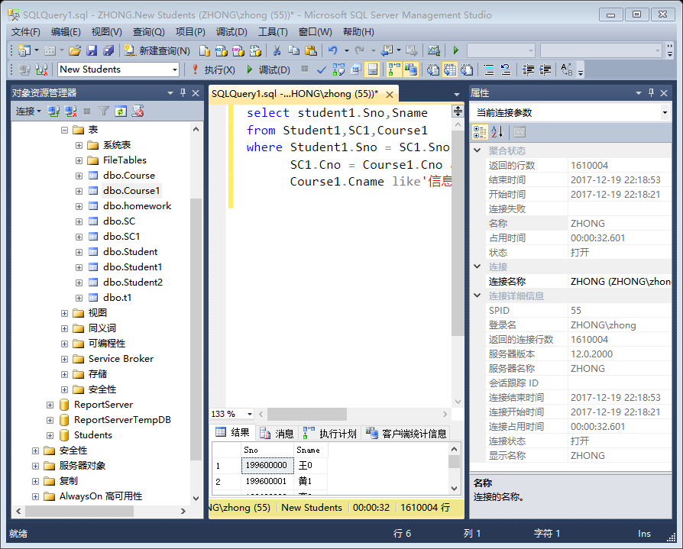

select Sno,Sname

from Student1

where Sno in (select Sno

from SC1

where Cno in (

select Cno from Course1

where Cname like'信息%'

)

)

